GRADUATING SENIORS:
WANT TO WORK IN A PSYCH LAB?

Apply to the SEEDS Lab!
SElf-regulation, Early Development, and Settings Lab
Directed by: Dr. Christine Li-Grining

If you are interested in getting research experience after graduation,
the SEEDS Lab may be right for you! We are looking for a new research coordinator
to become a part of our team.
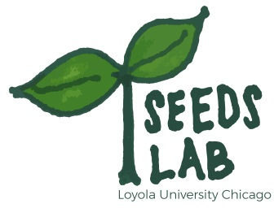

YOUR ROLE: The research coordinator will have the opportunity to help with data collection efforts, data analysis, papers, and grant proposals. You will also be a part of a larger team that includes other researchers from UIC and NYU.
OUR RESEARCH: In the SEEDS Lab, we study the development of preschoolers and youth from low-income and racial/ethnic minority backgrounds. Work on our research projects has helped prepare many students for graduate school programs.

WE ARE LOOKING FOR STUDENTS WHO…
- will have their undergraduate degree by the start of the position,
- have a GPA of 3.3 or greater,
- are available to work 15-20 hours every week for a year,
- although not a requirement, Spanish and Arabic speakers are strongly encouraged to apply,
- access to a car is a plus!

If you are interested in becoming a research coordinator in the SEEDS Lab, please email your resume and application to Dr. Jinyoung Koh at jkoh3@luc.edu (Post-Doctoral Researcher).
http://www.cpligrining.org/

